**Bugs List**

**If arrow is pointing from a picture, that picture is what the program actually shows.**

**If arrow is pointing to a picture, that picture is what the website (https://atlas.physicsmasterclasses.org/en/index.htm) says the program should show.**

MINERVA:

* Lego Plot only in 2-D
* Lego Plot doesn’t show Missing ET box

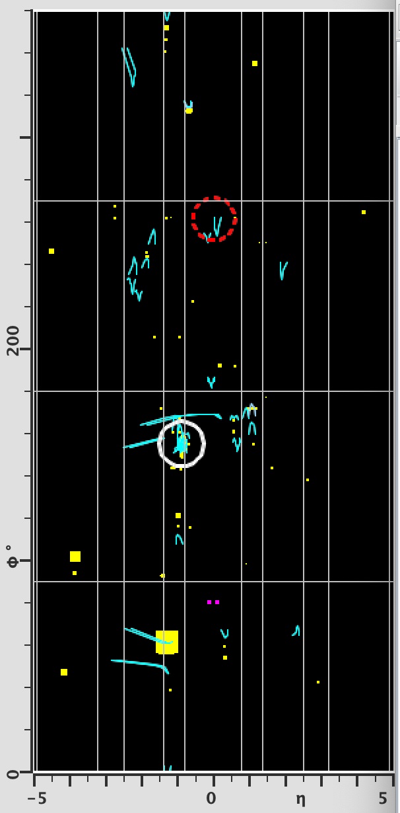 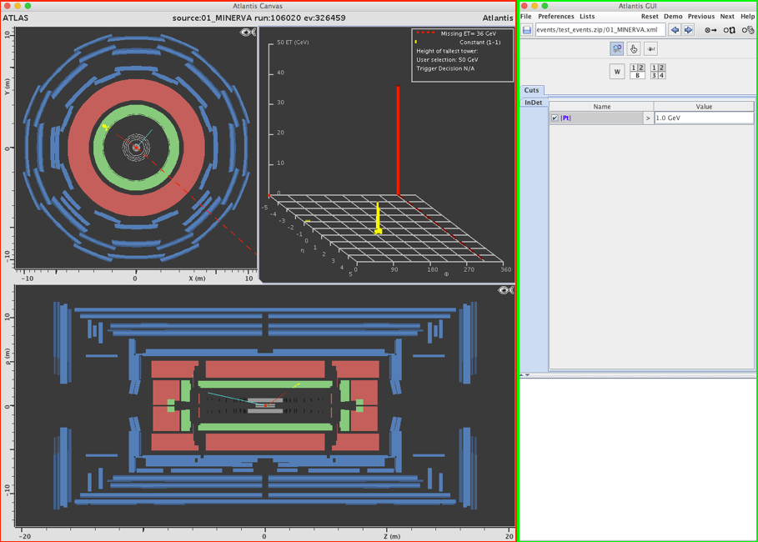

* Charge and Isolation numbers not shown in the information box.

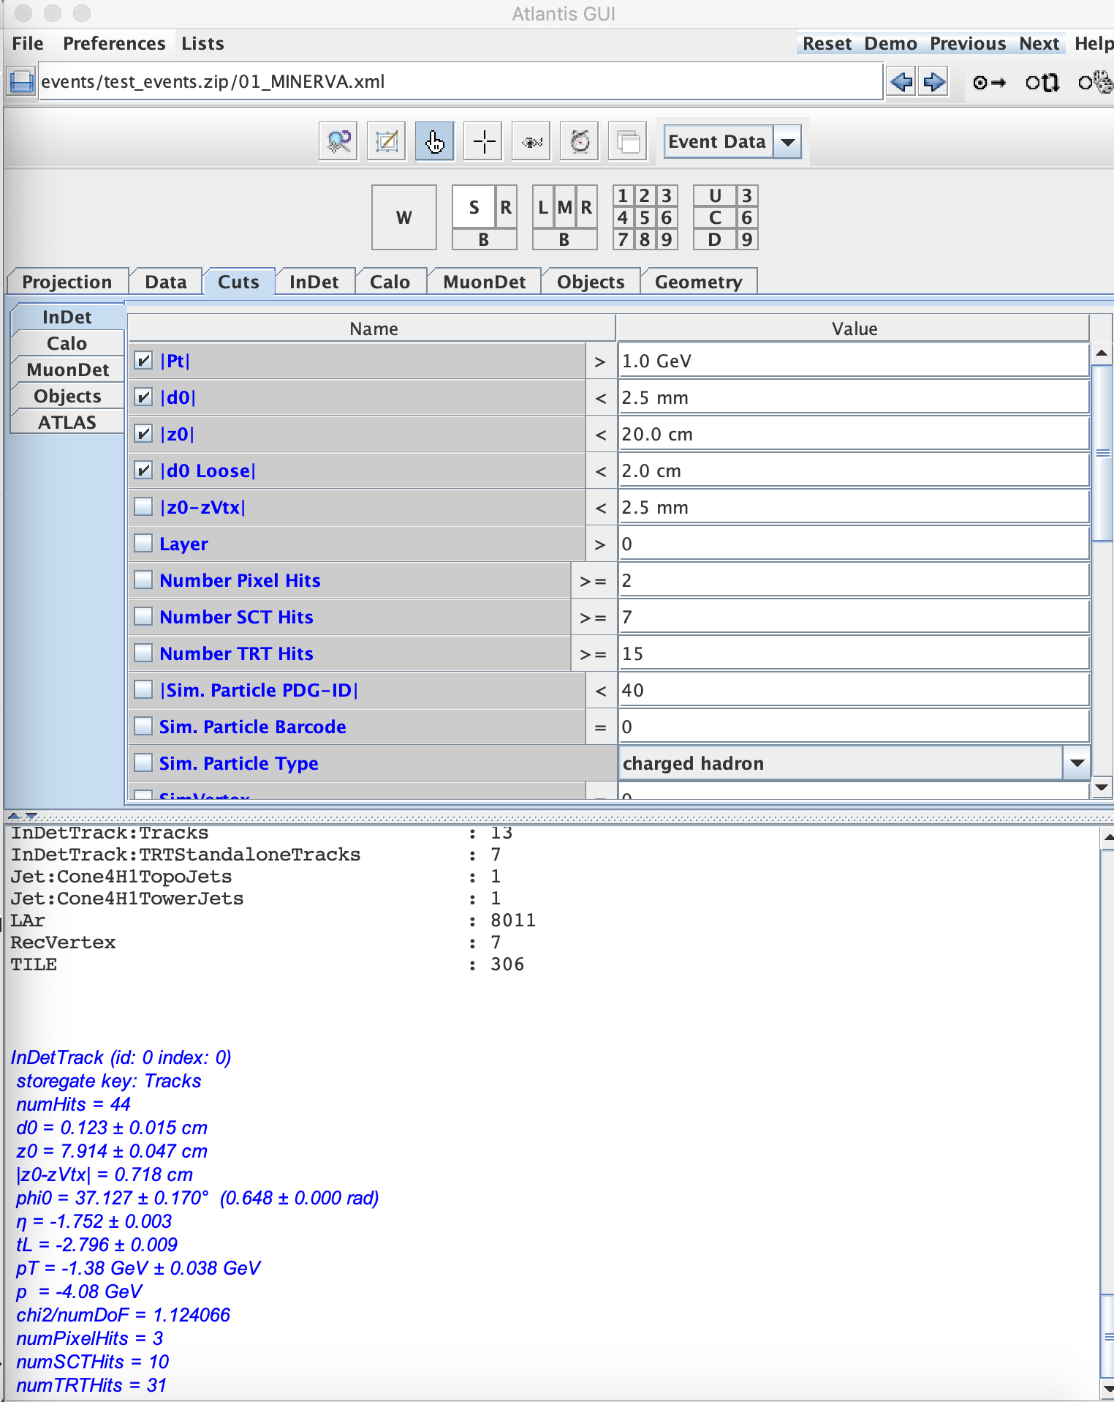 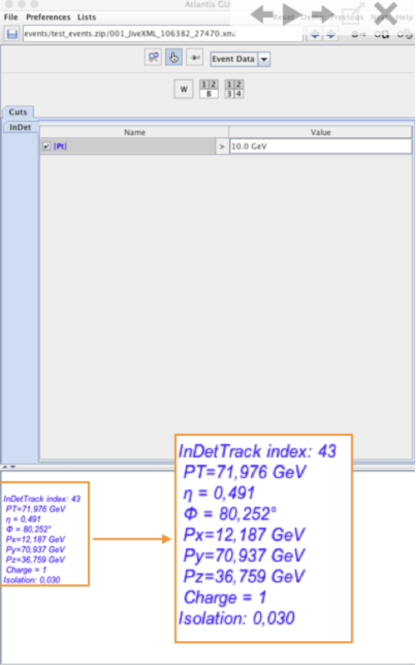

HYPATIA:

* Lego Plot Inactive after initial launch of the program. Need to load an exercise file first to activate the plot.

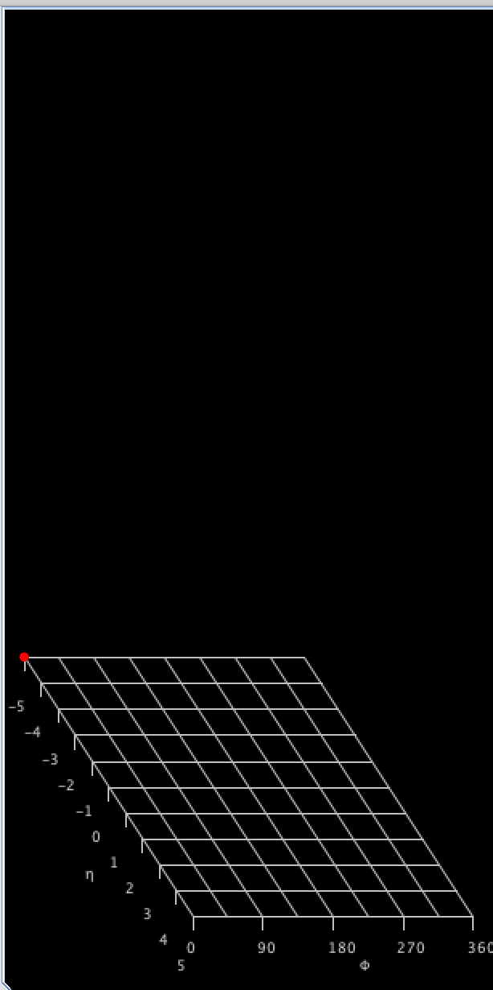 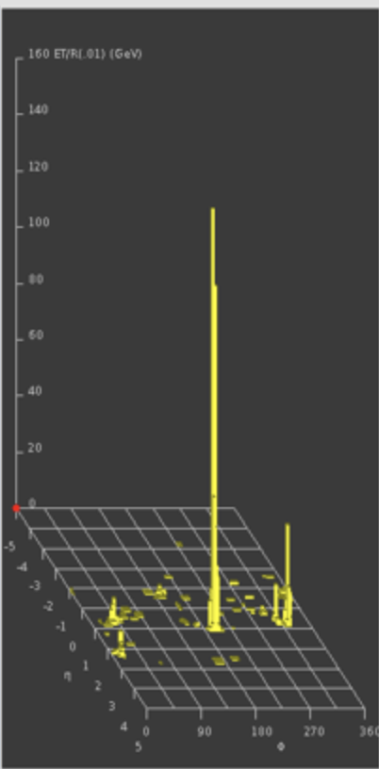

* Lego plot doesn’t show missing ET box

